RCM 49528
Title: Outcome Stratification In Non-ST-Segment Elevation Myocardial Infarction: Standardized Assessment Of Left Ventricular Global Longitudinal Strain
Supplementary Materials
This supplementary file provides additional figures and tables supporting the incremental prognostic value, internal validation, interaction analyses, and power context.
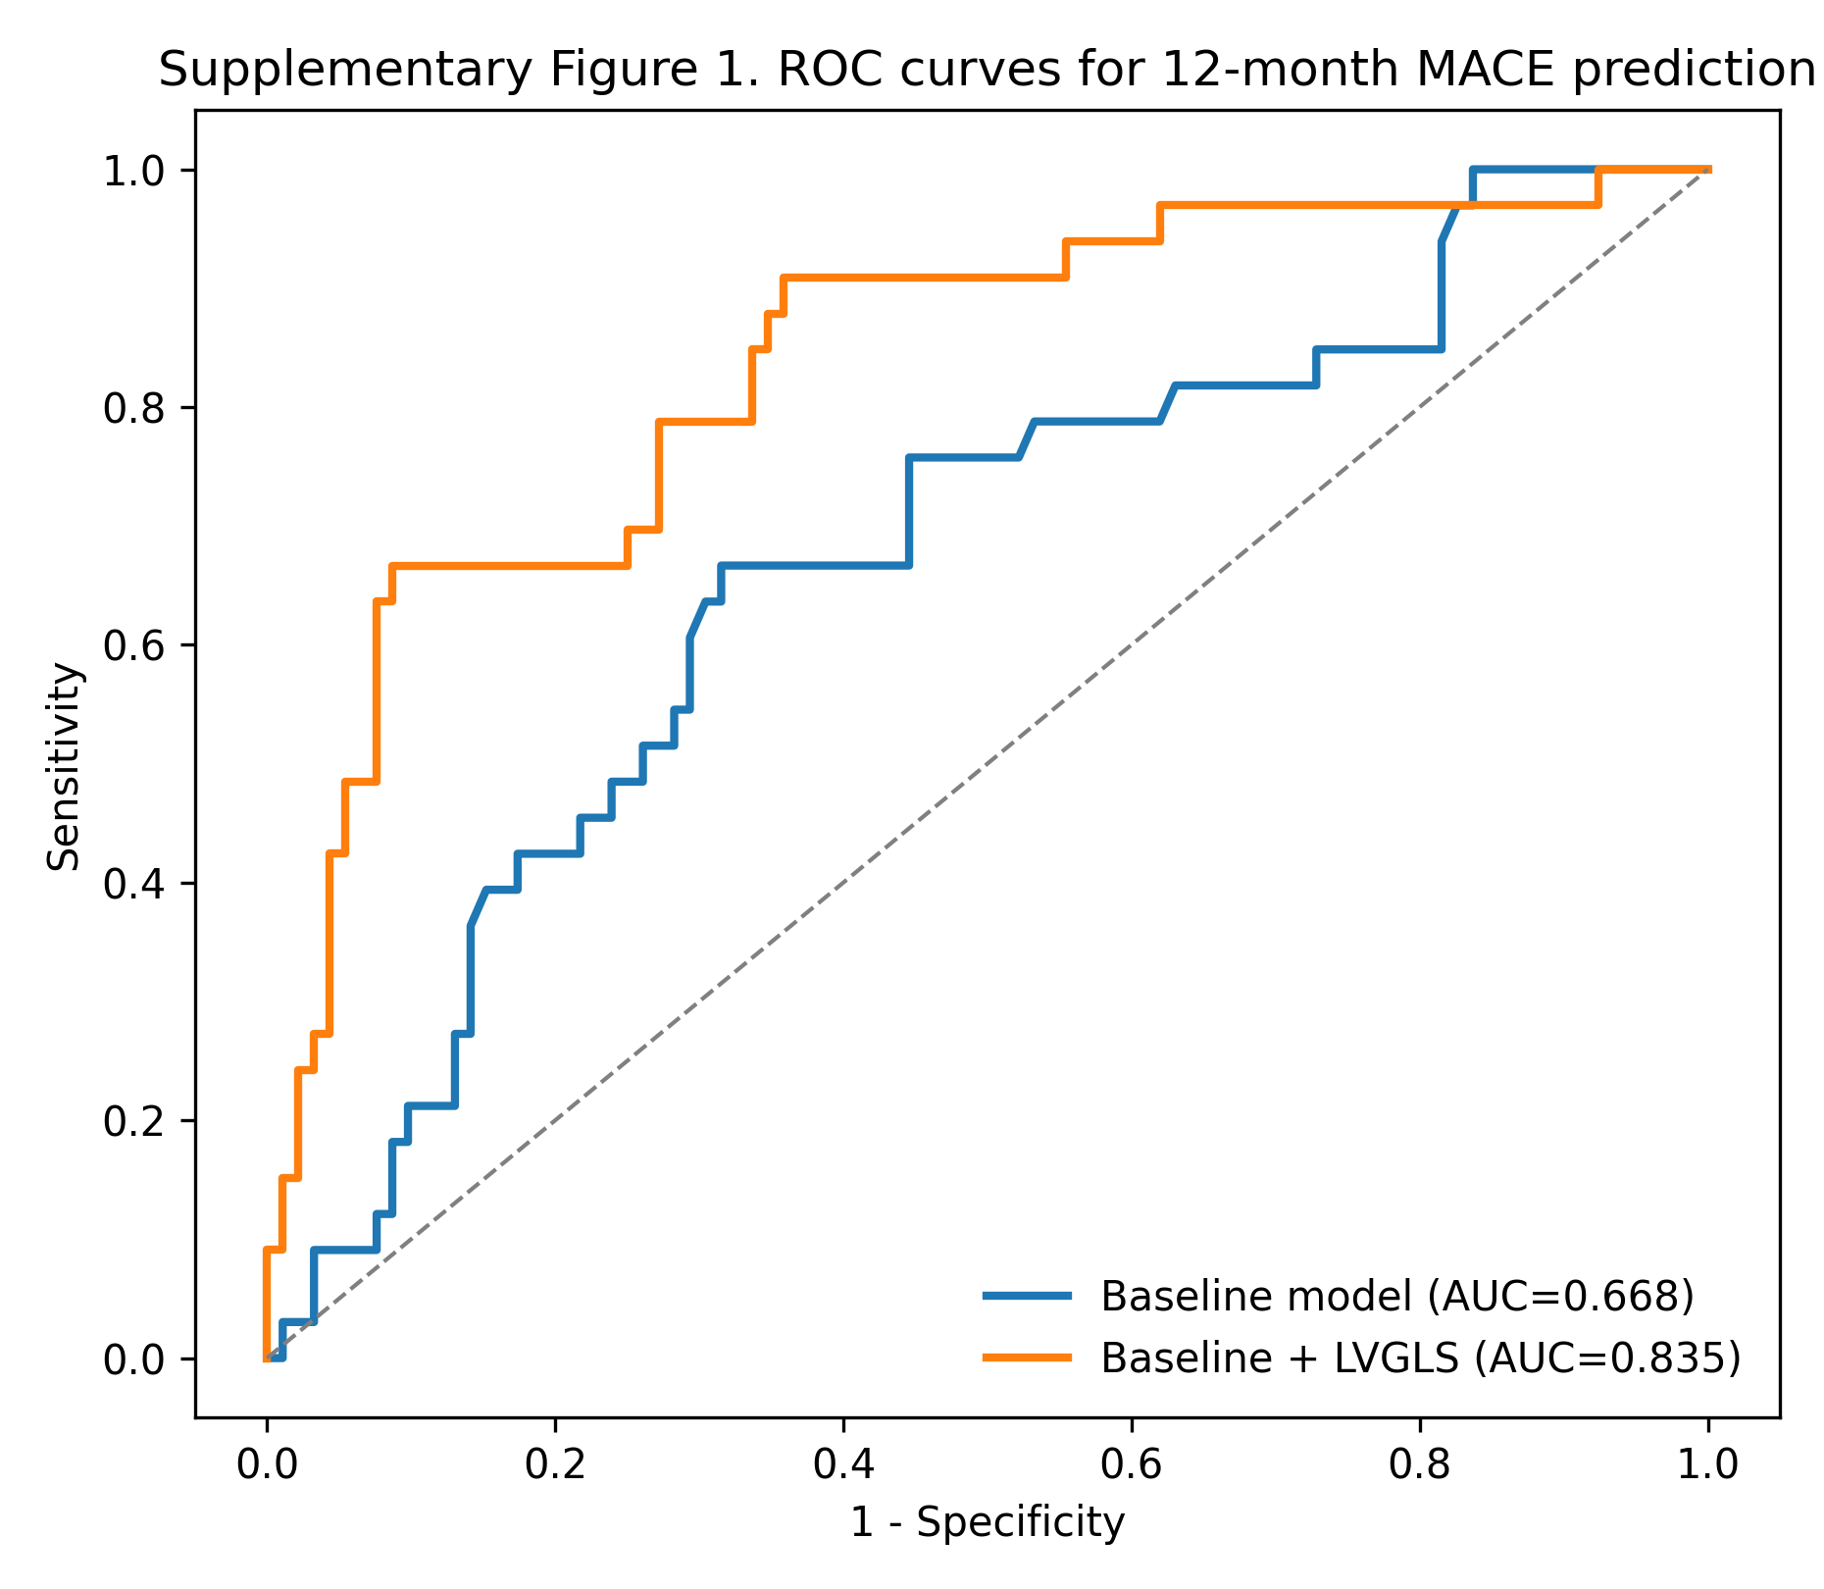

Supplementary Fig. 1. ROC curves for 12-month MACE prediction. Receiver operating characteristic curves comparing the baseline clinical model (GRACE score, diabetes, and Killip classification) with the extended model including LVGLS.
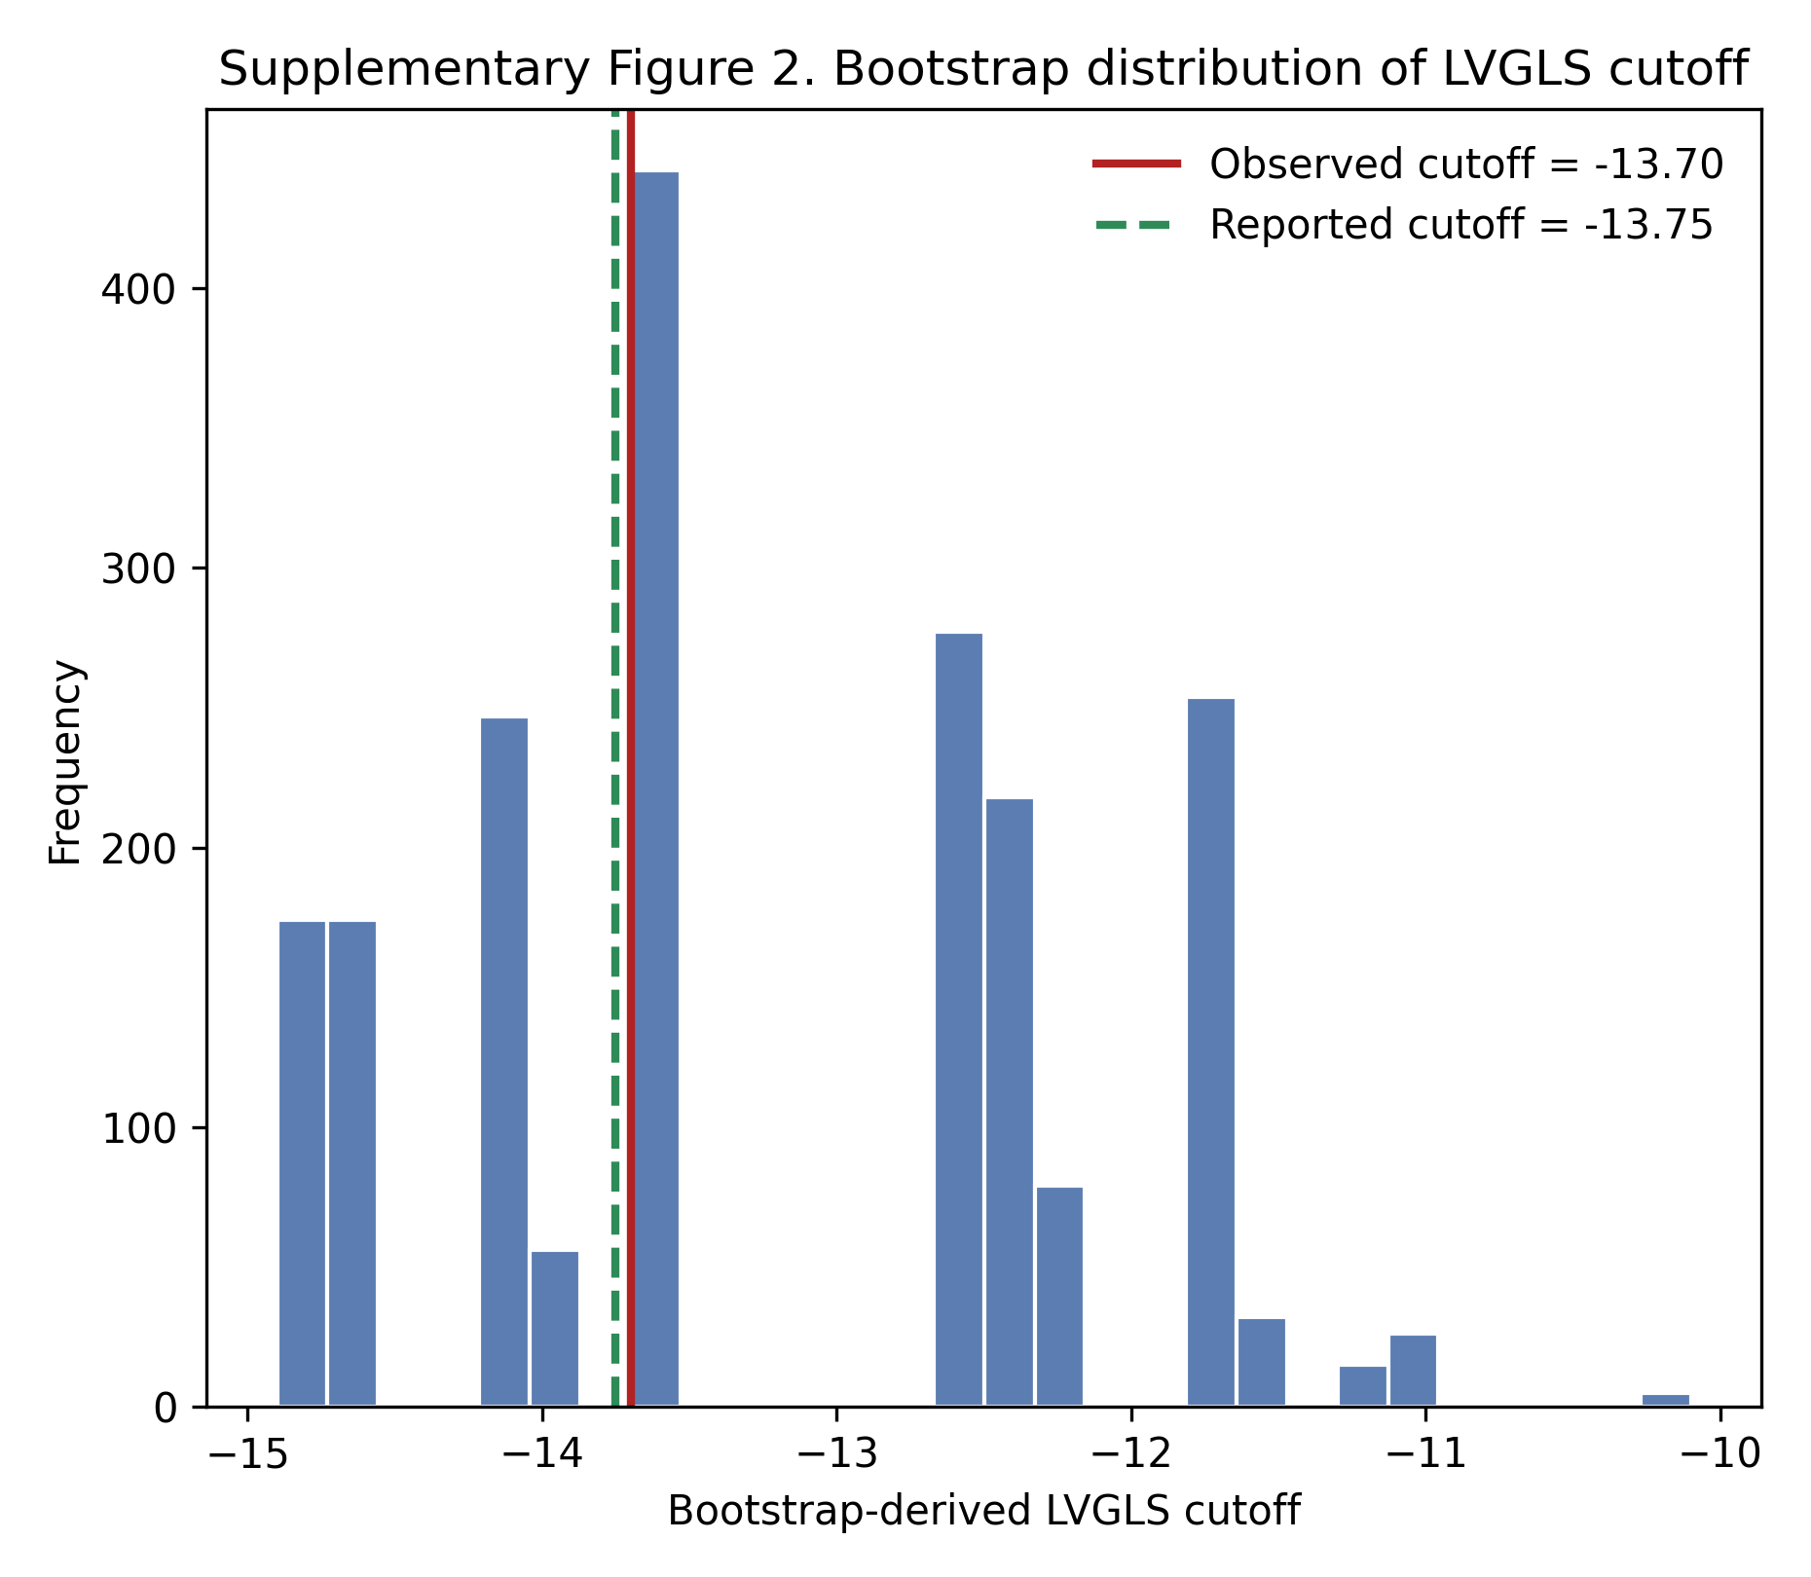

Supplementary Fig. 2. Bootstrap distribution of the LVGLS cutoff. Histogram of bootstrap-derived LVGLS cutoffs showing the stability of the Youden-derived threshold. The solid red line indicates the observed cutoff, and the dashed green line indicates the reported cutoff of -13.75%.
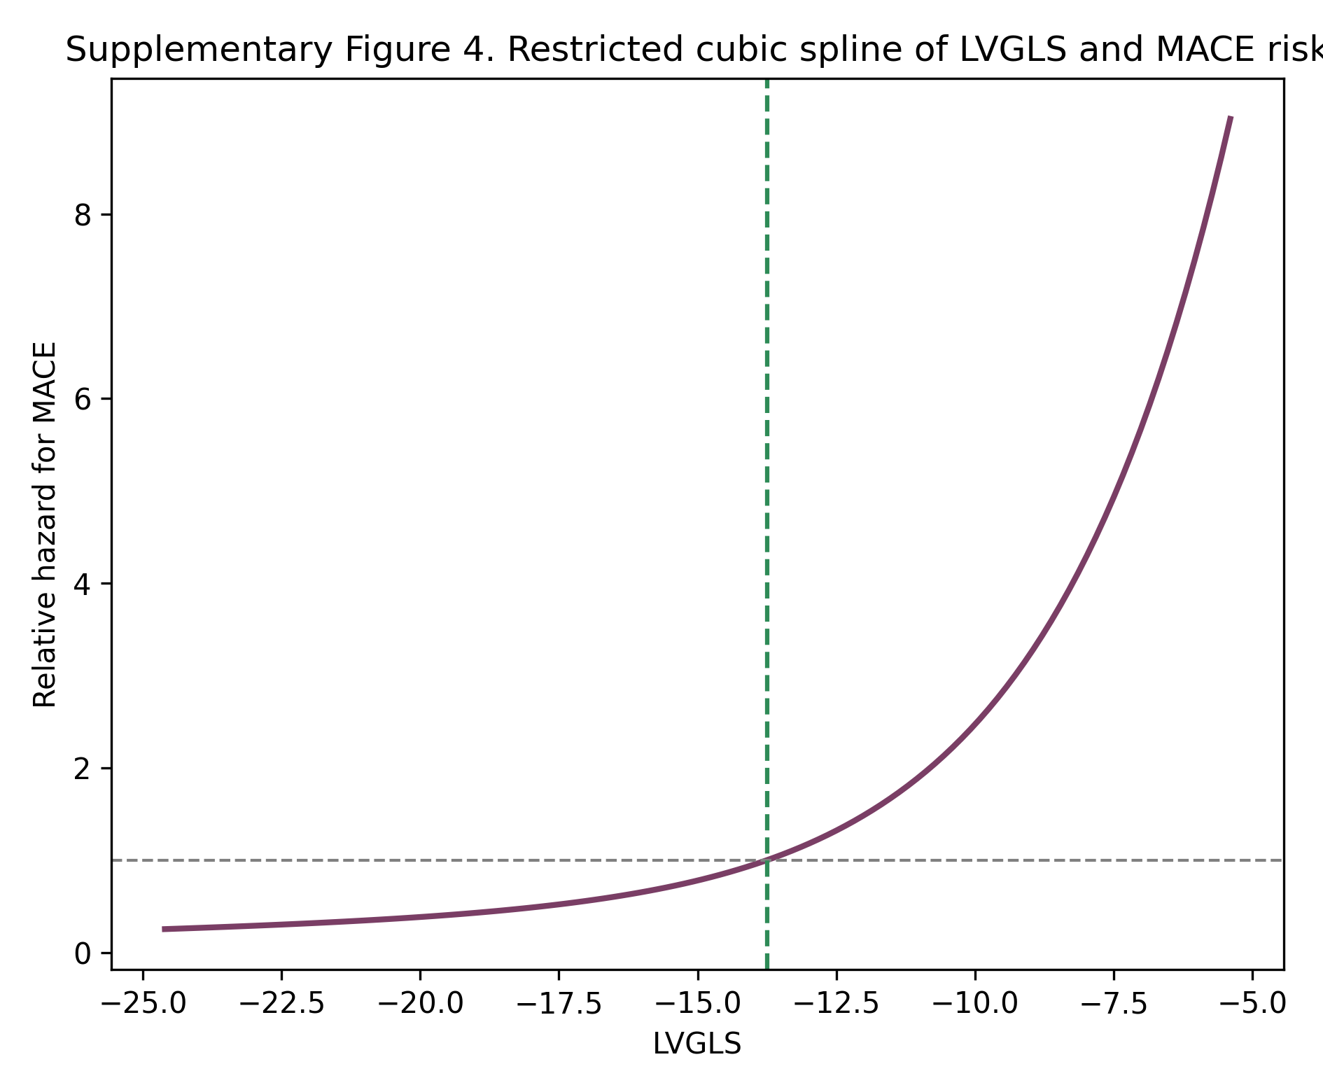

Supplementary Fig. 3. Restricted cubic spline of LVGLS and MACE risk. Restricted cubic spline analysis illustrating the dose-response relationship between LVGLS and MACE risk. No clear evidence of marked nonlinearity was observed in this cohort.
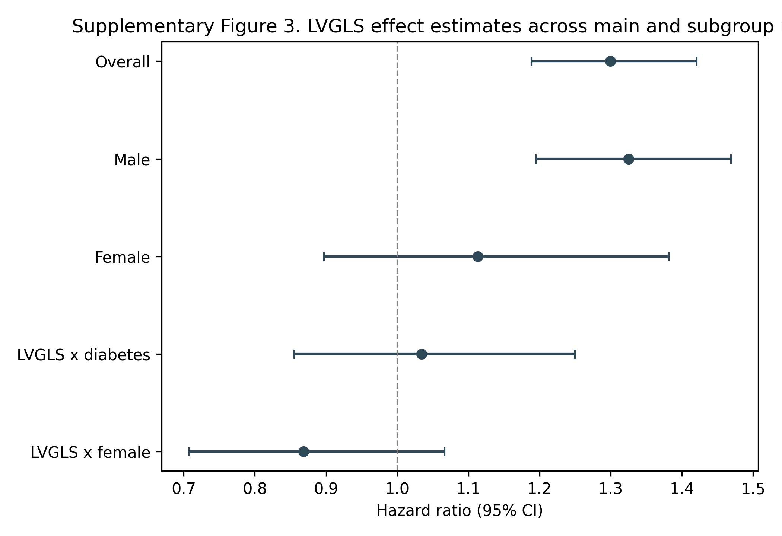

Supplementary Fig. 4. Forest plot of LVGLS effect estimates. Hazard ratio estimates for LVGLS in the overall model, sex-stratified models, and interaction analyses.

Supplementary Table 1. Cox regression models.
Model | covariate | coef | HR | SE | p | HR_95L | HR_95U
Main model | grace | 0.0 | 1.0 | 0.0 | 0.67 | 0.99 | 1.01
Main model | diabetes | 0.14 | 1.15 | 0.32 | 0.66 | 0.61 | 2.17
Main model | killip_high | 0.24 | 1.27 | 0.38 | 0.52 | 0.61 | 2.67
Main model | gls | 0.26 | 1.3 | 0.05 | 0.0 | 1.19 | 1.42
Diabetes interaction model | grace | 0.0 | 1.0 | 0.0 | 0.66 | 0.99 | 1.01
Diabetes interaction model | diabetes | 0.5 | 1.65 | 1.09 | 0.64 | 0.2 | 13.9
Diabetes interaction model | killip_high | 0.25 | 1.29 | 0.38 | 0.5 | 0.61 | 2.71
Diabetes interaction model | gls | 0.25 | 1.29 | 0.05 | 0.0 | 1.16 | 1.43
Diabetes interaction model | gls_x_diabetes | 0.03 | 1.03 | 0.1 | 0.73 | 0.86 | 1.25
Sex interaction model | grace | 0.0 | 1.0 | 0.0 | 0.85 | 0.99 | 1.01
Sex interaction model | diabetes | 0.21 | 1.23 | 0.33 | 0.53 | 0.64 | 2.34
Sex interaction model | killip_high | 0.35 | 1.42 | 0.38 | 0.35 | 0.68 | 2.99
Sex interaction model | gls | 0.29 | 1.33 | 0.05 | 0.0 | 1.2 | 1.48
Sex interaction model | female | -1.93 | 0.14 | 1.33 | 0.15 | 0.01 | 1.97
Sex interaction model | gls_x_female | -0.14 | 0.87 | 0.1 | 0.18 | 0.71 | 1.07
Male subgroup | grace | 0.0 | 1.0 | 0.01 | 0.59 | 0.99 | 1.01
Male subgroup | diabetes | 0.24 | 1.27 | 0.38 | 0.53 | 0.6 | 2.68
Male subgroup | killip_high | 0.25 | 1.29 | 0.41 | 0.54 | 0.58 | 2.87
Male subgroup | gls | 0.28 | 1.33 | 0.05 | 0.0 | 1.2 | 1.47
Female subgroup | grace | -0.01 | 0.99 | 0.01 | 0.52 | 0.97 | 1.02
Female subgroup | diabetes | 0.29 | 1.34 | 0.77 | 0.71 | 0.29 | 6.09
Female subgroup | killip_high | 1.06 | 2.89 | 1.11 | 0.34 | 0.33 | 25.55
Female subgroup | gls | 0.11 | 1.11 | 0.11 | 0.33 | 0.9 | 1.38
Detailed coefficients, hazard ratios, confidence intervals, and p-values for the main, interaction, and subgroup Cox models.

Supplementary Table 2. Incremental prognostic value of LVGLS.
Model | N | Events | C_index | AUC_12m | Delta_AUC_12m | Continuous_NRI | IDI
Base model | 181 | 40 | 0.67 | 0.67 | nan | nan | nan
Base + LVGLS | 181 | 40 | 0.81 | 0.84 | 0.17 | 0.96 | 0.22
Summary of model discrimination before and after adding LVGLS to the baseline clinical model.

Supplementary Table 3. Bootstrap validation and reclassification metrics.
Metric | Observed | Bootstrap_mean | CI_95_L | CI_95_U | P_bootstrap
Delta AUC | 0.17 | 0.171 | 0.07 | 0.28 | 0.0
Continuous NRI | 0.96 | 0.99 | 0.59 | 1.38 | 0.0
IDI | 0.22 | 0.25 | 0.12 | 0.39 | 0.0
LVGLS cutoff | -13.7 | -13.26 | -14.9 | -11.5 | nan
Bootstrap-derived estimates for delta AUC, continuous NRI, IDI, and LVGLS cutoff stability.

Supplementary Table 4. Post-hoc power context.
Endpoint | Events | LVGLS_threshold_HR | Threshold_positive_proportion | Approx_post_hoc_power
Composite MACE | 40 | 6.46 | 0.37 | 1.0
Event-based post-hoc power context for the primary LVGLS threshold analysis.

